
Venue Contact Capacity

Non Traditional Venues
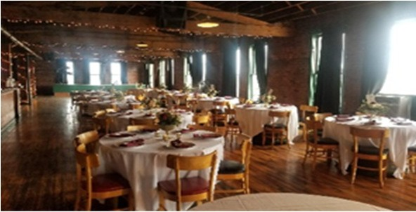
4th Floor Blues Club
(765) 966-5654
4parker.com/4th-floor-blues- club.html
300
923 N E Street

Richmond, IN 47374
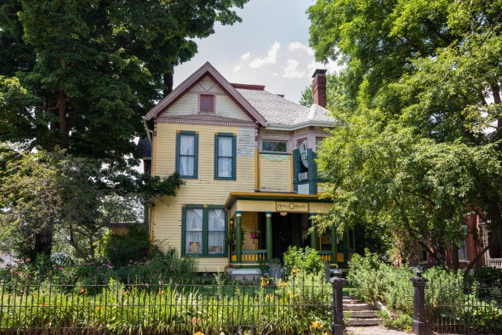
Arden Health

202 North 15th Street
15
Richmond, IN 47374
sims48@msn.com
ardenhearth.com

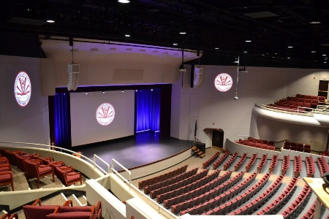

Civic Hall Performing Arts Center

380 Hub Etchison Pkwy. Richmond, IN 47374
Dougherty Orchard

(765) 973-3350
243 N Dougherty Rd, Cambridge City, IN 47327

Eight to the Bar
(765) 598-5115
933 E Main St, Richmond, IN 47374
400

(765) 973-3350
civichall.com

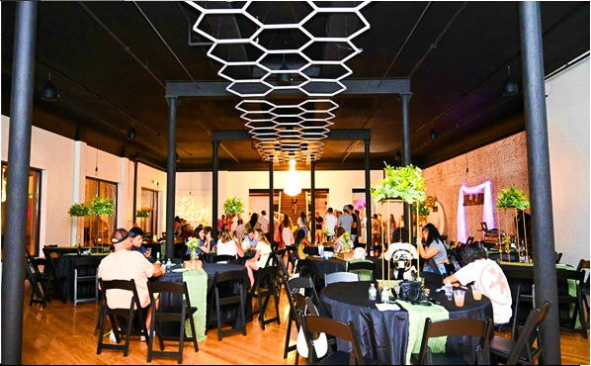
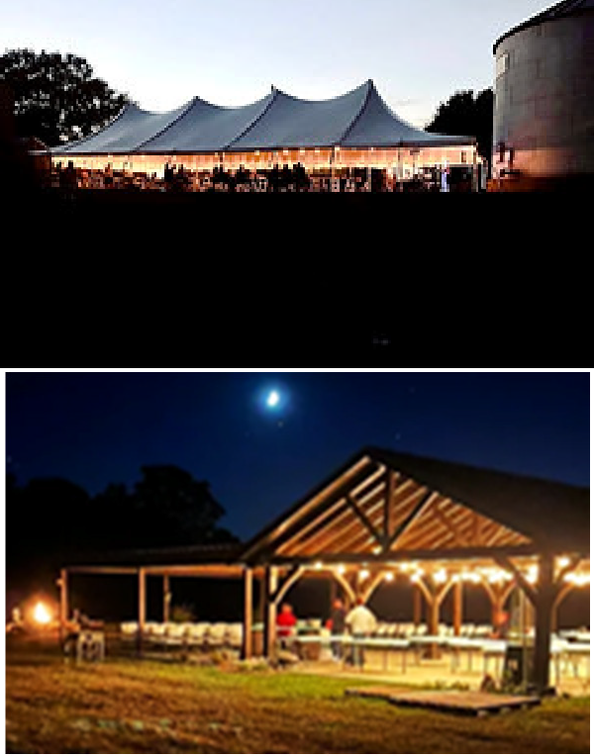
930

Cope Environmental Center

4910 Shoemaker Road

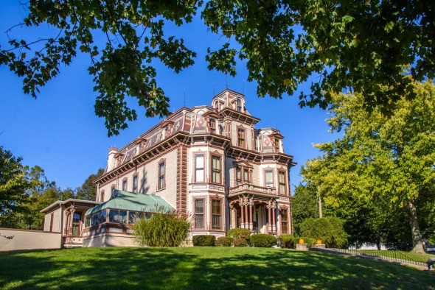
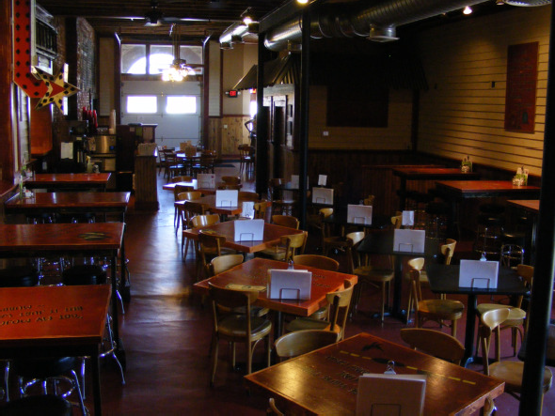
Richmond, IN 47374 Earlham College 801 National Rd East Richmond, IN 47374
Firehouse BBQ & Blues

400 N 8th Street
(765) 488-0312
firehousebbqand- blues.com/
80
Richmond, IN 47374

Gaar House & Farm Museum

2593 Pleasant View Rd
Call for
Info
Richmond, IN 47374
(765) 966-1262
thegaarhouse.com/

Glen Miller Park Recreational Facilities
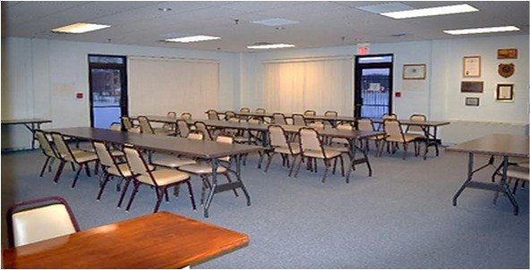
2200 National Rd E Richmond, IN 47374
Golay Center

1007 East Main St
(765) 478-5565
golaycenter.com/
100
Cambridge City, IN 47327

(765) 855-3188
copeenvironmental.org

(765) 983-1200

earlham.edu

(765) 983-7275
richmondindiana.gov/ location/glen-miller-park
Call for Info

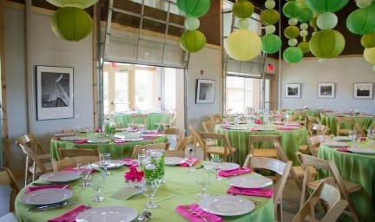
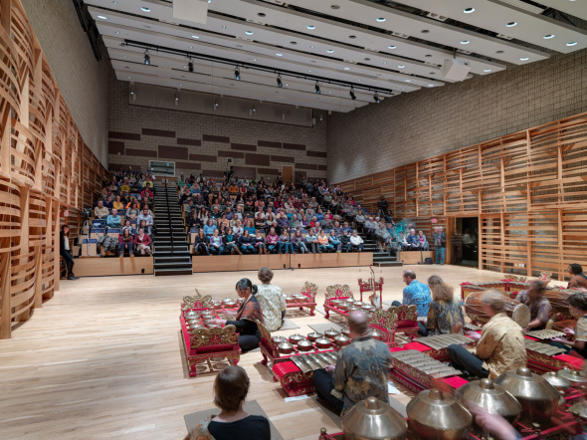
Call for Info

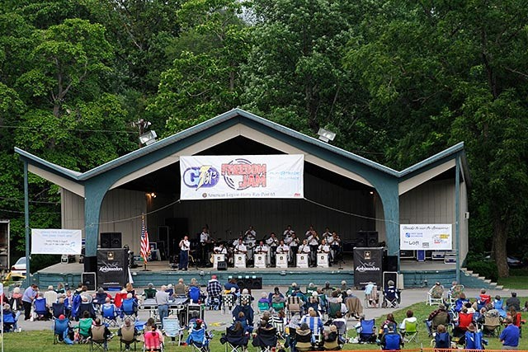
Call for Info

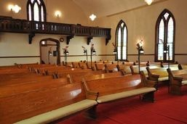
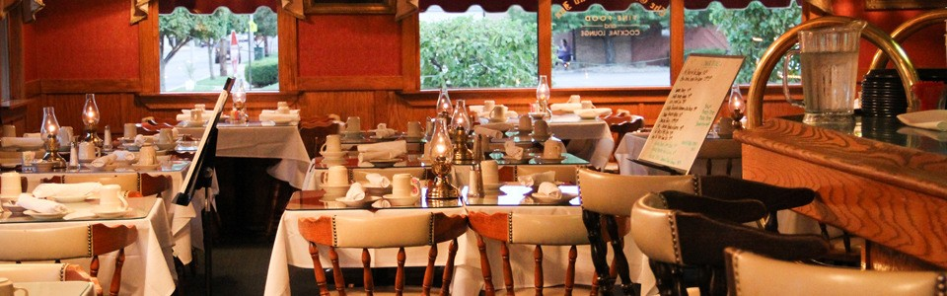
Olde North Chapel
(765) 962-3627
theoldenorthchapel.com/
120
200 North 11th Street Richmond, IN 47374

Old Richmond Inn
138 South 5th Street
(765) 962-2247
oldrichmondinn.com/
Richmond, IN 47374

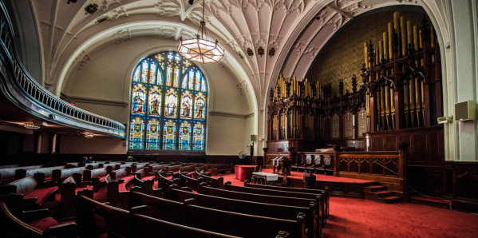
Reid Center
1004 N A Street
300
Richmond, IN 47374
(765) 960-7730
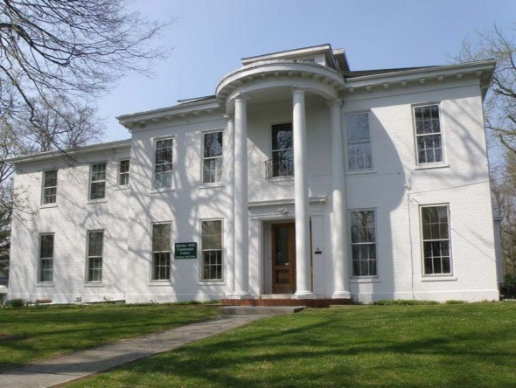
richmondcolumbianproperties.org/
Quaker Hill Conference Center

10 Quaker Hill Drive
100
Richmond, IN 47374
(765) 962-5741
qhcc.org/

Richmond Columbian Properties William G. Scott House
( First Bank Gallery Hall)

Richmond Art Museum 350 Hub Etchison Parkway Richmond, IN 47374

Richmond Rose Garden

East Main St Richmond, IN 47374

(765) 966 - 0256

(765) 983-7275
richmondartmuseum.org/

(765) 983-7275
500 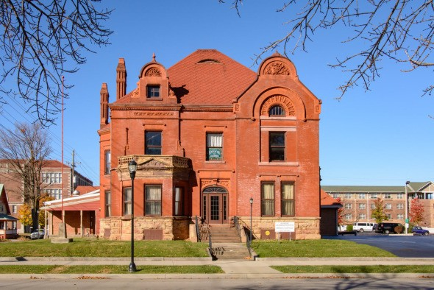
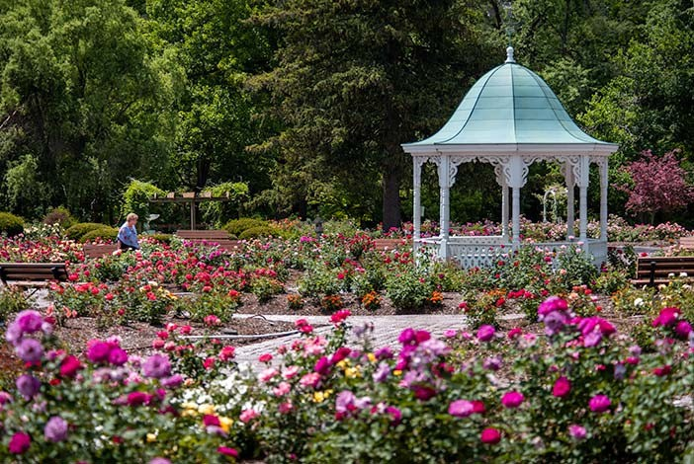
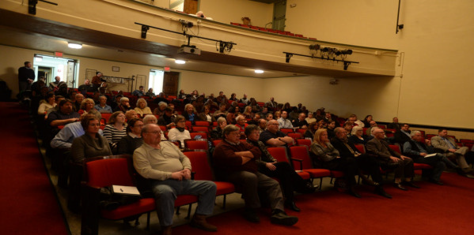
Call for Info

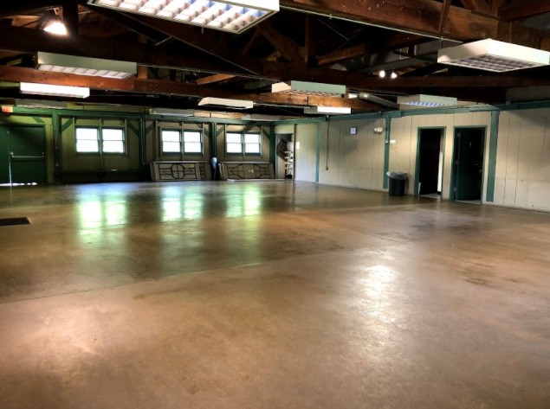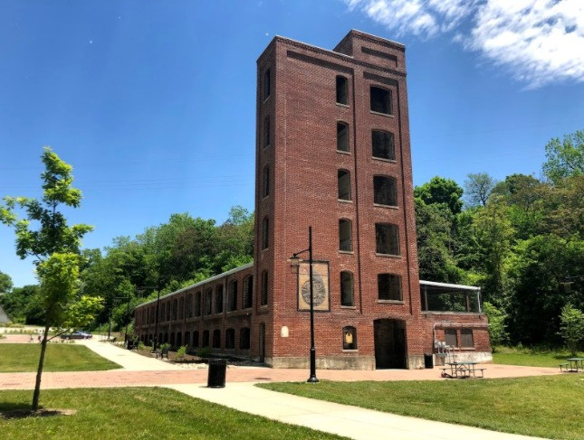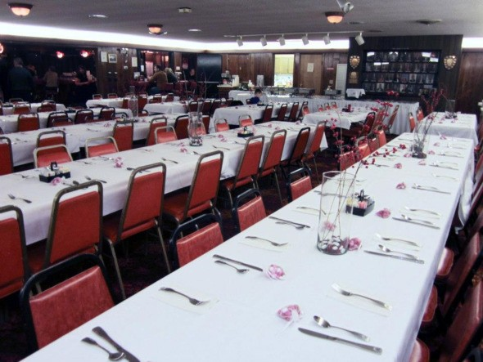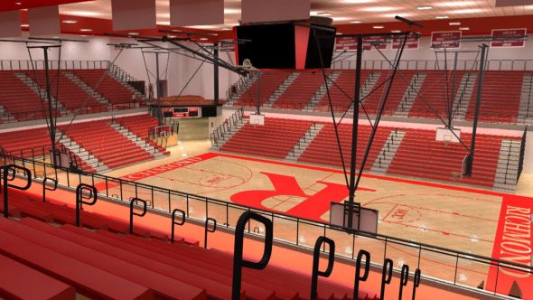
Springwood Park—Cabin
(765) 983-7275
64 Waterfall Rd

Richmond, IN 47374
richmondindiana.gov/ location/springwood-park-
shelters
75
Starr Gennett Building
101 South 1st Street Richmond, IN 47374
(765) 983-7275
richmondindiana.gov/ location/starr-gennett-building
600
Tarum Shrine

3988 State Road 227 S

Richmond, IN 47374
(765) 935-1045
facebook.com/Tarum-Shrine- Club-161134383953053/
125
Tiernan Center
380 Hub Etchison Pkwy 6,500
Richmond, IN 47374 (765) 973-3316

Wayne County Fairgrounds & Exposition Center
861 N Salisbury Rd Richmond, IN 47374
First Bank Kuhlman Center

20,000 Square Feet

Capacity: 3,000 First Bank Expo Hall 37,500 Square Feet

Capacity: 6,500

(765) 935-6291

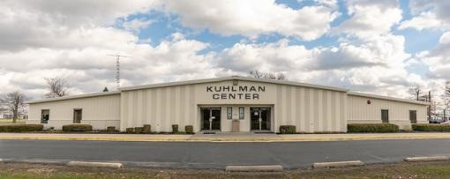
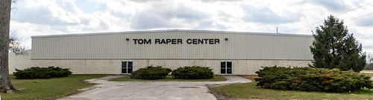

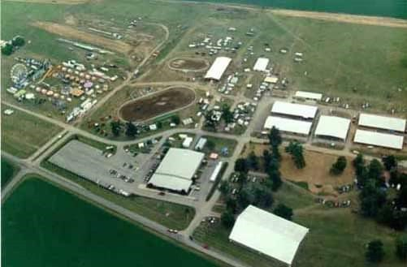
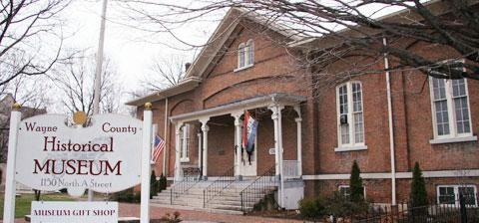
Wayne County Historical Museum

1150 N A Street
(765) 962-5756
wchmuseum.org/
Call for
Info
Richmond, IN 47374

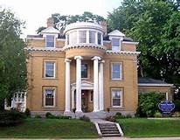
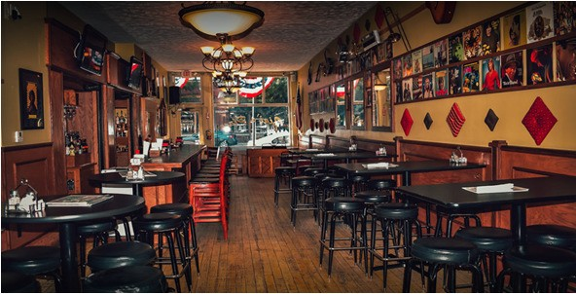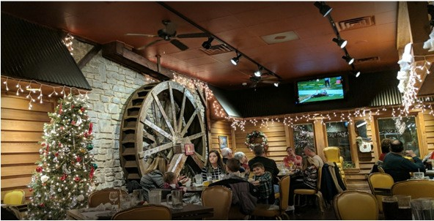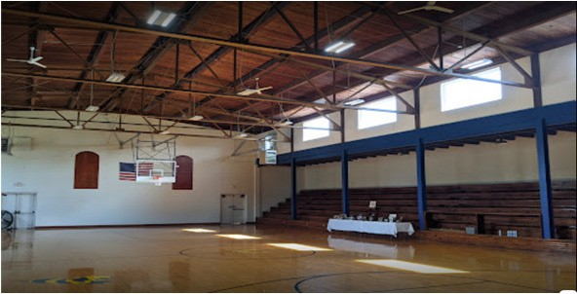
Williamsburg Community Center

8500 North Centerville Rd
(765) 866-4448
800
Williamsburg, IN 47393

Willie & Red’s

40 East Main Street
Call for
Info
Hagerstown, IN 47346
(765) 489-4131
willieandreds.com/

Little Sheeba’s

175 Fort Wayne Ave.
(765) 962-2999
littleshebas.com/
50
Richmond, IN 47374

Shady Nook

8193 College Corner Road Centerville, Indiana 47330

(765)935-0055

Gennett Mansion

1829 E Main St, Richmond, IN,

(765)-914-0432

