
WEDDING VENUES
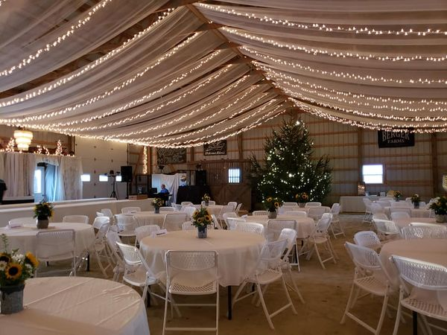
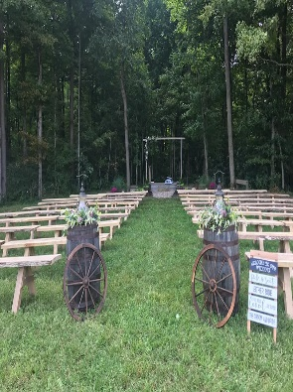
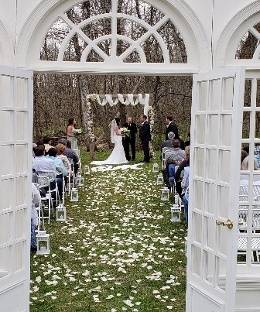
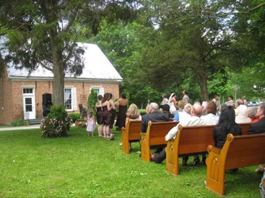
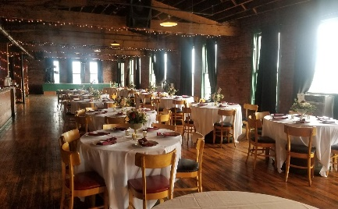
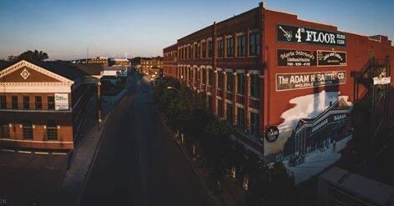
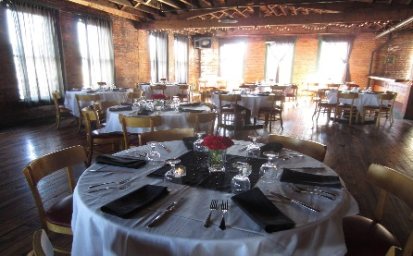
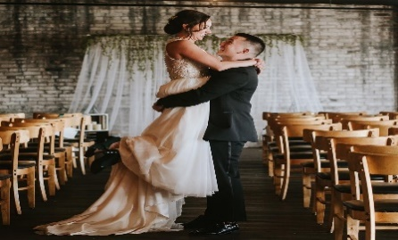
INDOOR VENUES
Peacefulness and Tranquility transcend this property making it the perfect backdrop for your wedding. The 1858 Meeting House is simple in design allowing you to create an ambiance to fit your style. The 180 seat capacity sanctuary is filled with natural light and wonderful acoustics. There are several outdoor vignettes that are quite suitable for ceremonies of any size. At the Historic Meeting House at New Garden, the ceremony can easily move inside should the weather prevail. The building is equipped with central heat and a/c, a portable/wireless sound system with mp3/cd integration, Wi-Fi, an electronic keyboard, organ, piano, natural oak pews, a large format video screen, banquet tables, and folding chairs.

The Historic Meeting House at New Garden
Phone: (765) 874-1649
Email: QuakerTrace@yahoo.com

4th Floor Blues Club
Phone: (765) 247-0567
Email: events@4parker.com
Take a step back in time in the over 100 year old building complete with a freight elevator and operator which will transport you to our fourth floor. Once there you will see exposed brick, wood beams and custom wood tables which will accommodate over 300 people. They offer a separate room for your ceremony, reception and a bridal suite.
Another great amenity of this venue is that it has an on-site caterer for all of your needs. Maria Mitrione’s Catering has set the standard for excellence in and around Richmond. Their commitment to using the freshest, high quality ingredients combined with their professionalism and flexibility promises to make your wedding event a success.
Catering Info:
Phone: (765) 939-4152
Email: kim.mason1963@gmail.com
Eight to the Bar
Phone: (937) 733-8783
Email: eighttothebarvenue@gmail.com

Springwood Chapel
Phone: (765) 983-7275
Email: parks@richmondindiana.gov
Create your perfect day with this unique, beautiful, and historic venue. Once home to Starr Piano and Gennett Records your guests will think they stepped back in time with the beauty of original woodwork, doors, signs and other unique features that will catch their eye, all while incorporating elegant, modern touches throughout the building. This climate-controlled venue seats up to 400 guests comfortably. While your guests are arriving downstairs, you will have full access upstairs in the lux bridal and groom suites. These luxurious rooms provide natural sunlight and a relaxing environment to calm your nerves on your big day. Once you’re are ready, you will make your grand entrance down the stunning original staircase, this entrance will be the talk of the town.
““Eight to the Bar” is a phrase from the Jump Blues era said when wanting a boogie beat, go “eight to the bar”. The call was to ask the band leader to play something to really dance to. In the spirit of our building’s history of music and good times, the venue will always go Eight to the Bar for you.”
The new chapel at Springwood is a beautiful venue for weddings and features a wooden chapel, rustic seating for about 90 people, and a beautiful flagstone walkway. It’s located in a secluded area of the park that allows for full privacy, but is also a short distance from the rest of the park. Rental of the Chapel includes full access to the Springwood pavilion as well, holding about 150 people. The pavilion has a full kitchen, electricity, parking, and bathrooms, making it the perfect place for wedding prep, a reception, catering, etc.

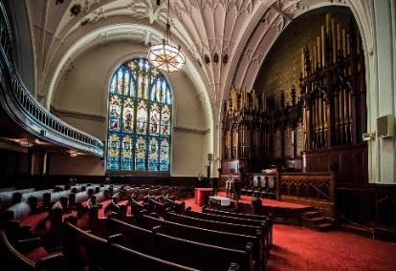
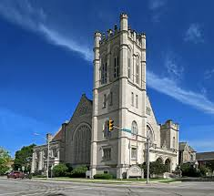

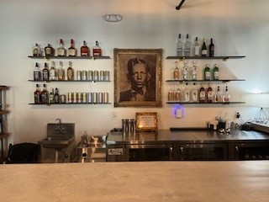
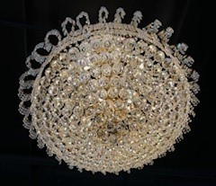
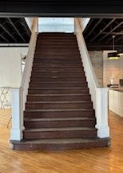
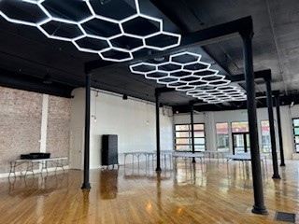
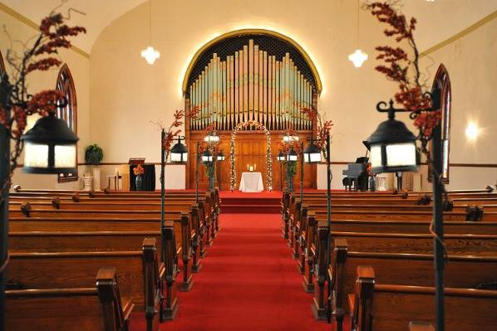
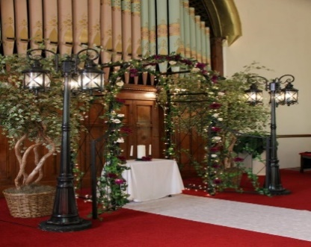
Reid Center
Phone: (765) 966-7618
Email: info@reidcenter.org

The historic Reid Memorial Church was built in 1906 and includes stained glass and fixtures designed by New York’s Tiffany family. Complementing the Tiffany windows are a dramatic fan-vaulted ceiling and historic Hook & Hastings organ. This building would serve as a beautiful background for your wedding and is sure to be remembered by guests.

The Olde North Chapel
Phone: (765) 962-3627
Email: ardene@oldenorthchapel.com
First Bank Kuhlman Center & Wayne County Farm Bureau Gazebo
Phone: (765) 935-6291
Email: hbaker@co.wayne.in.us
GAZEBO RENTAL FEE: $200/DAY
Donated by the Wayne County Farm Bureau, this beautiful new addition will serve as a great place to host wedding ceremonies, family reunions, small concerts, and more! 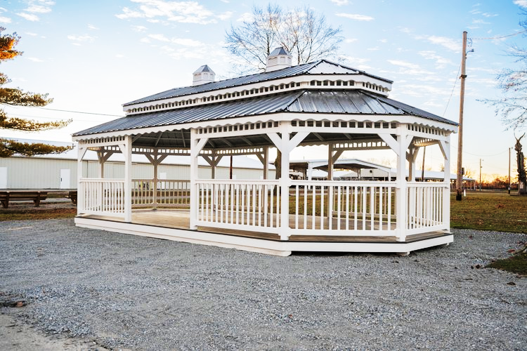
First Bank Kuhlman Center: Call for rental information 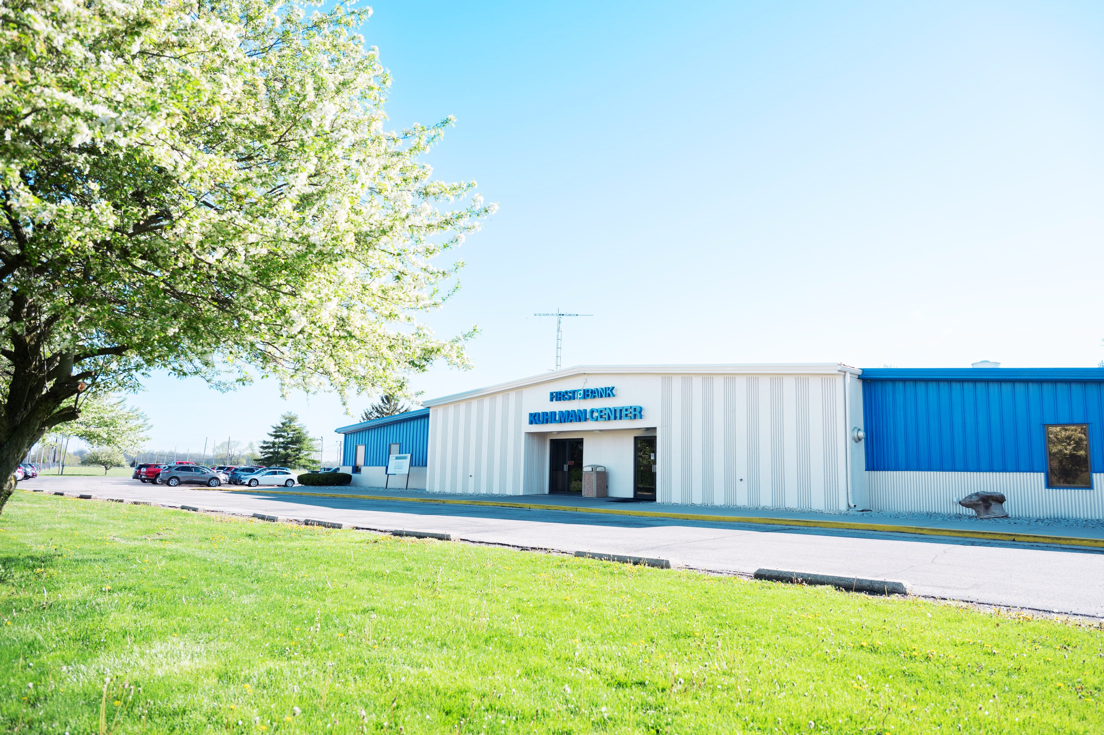
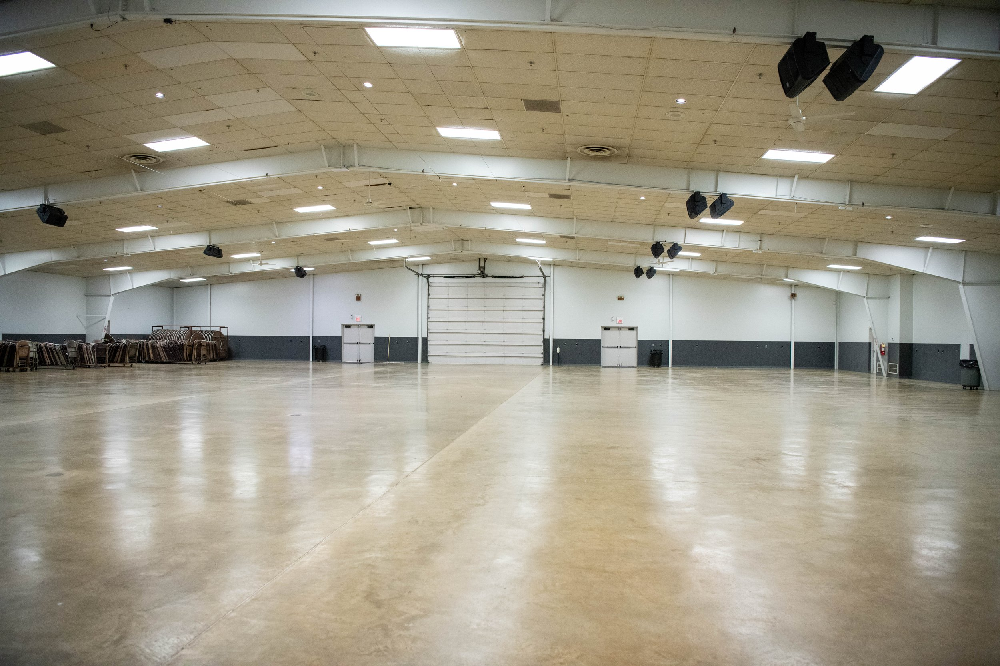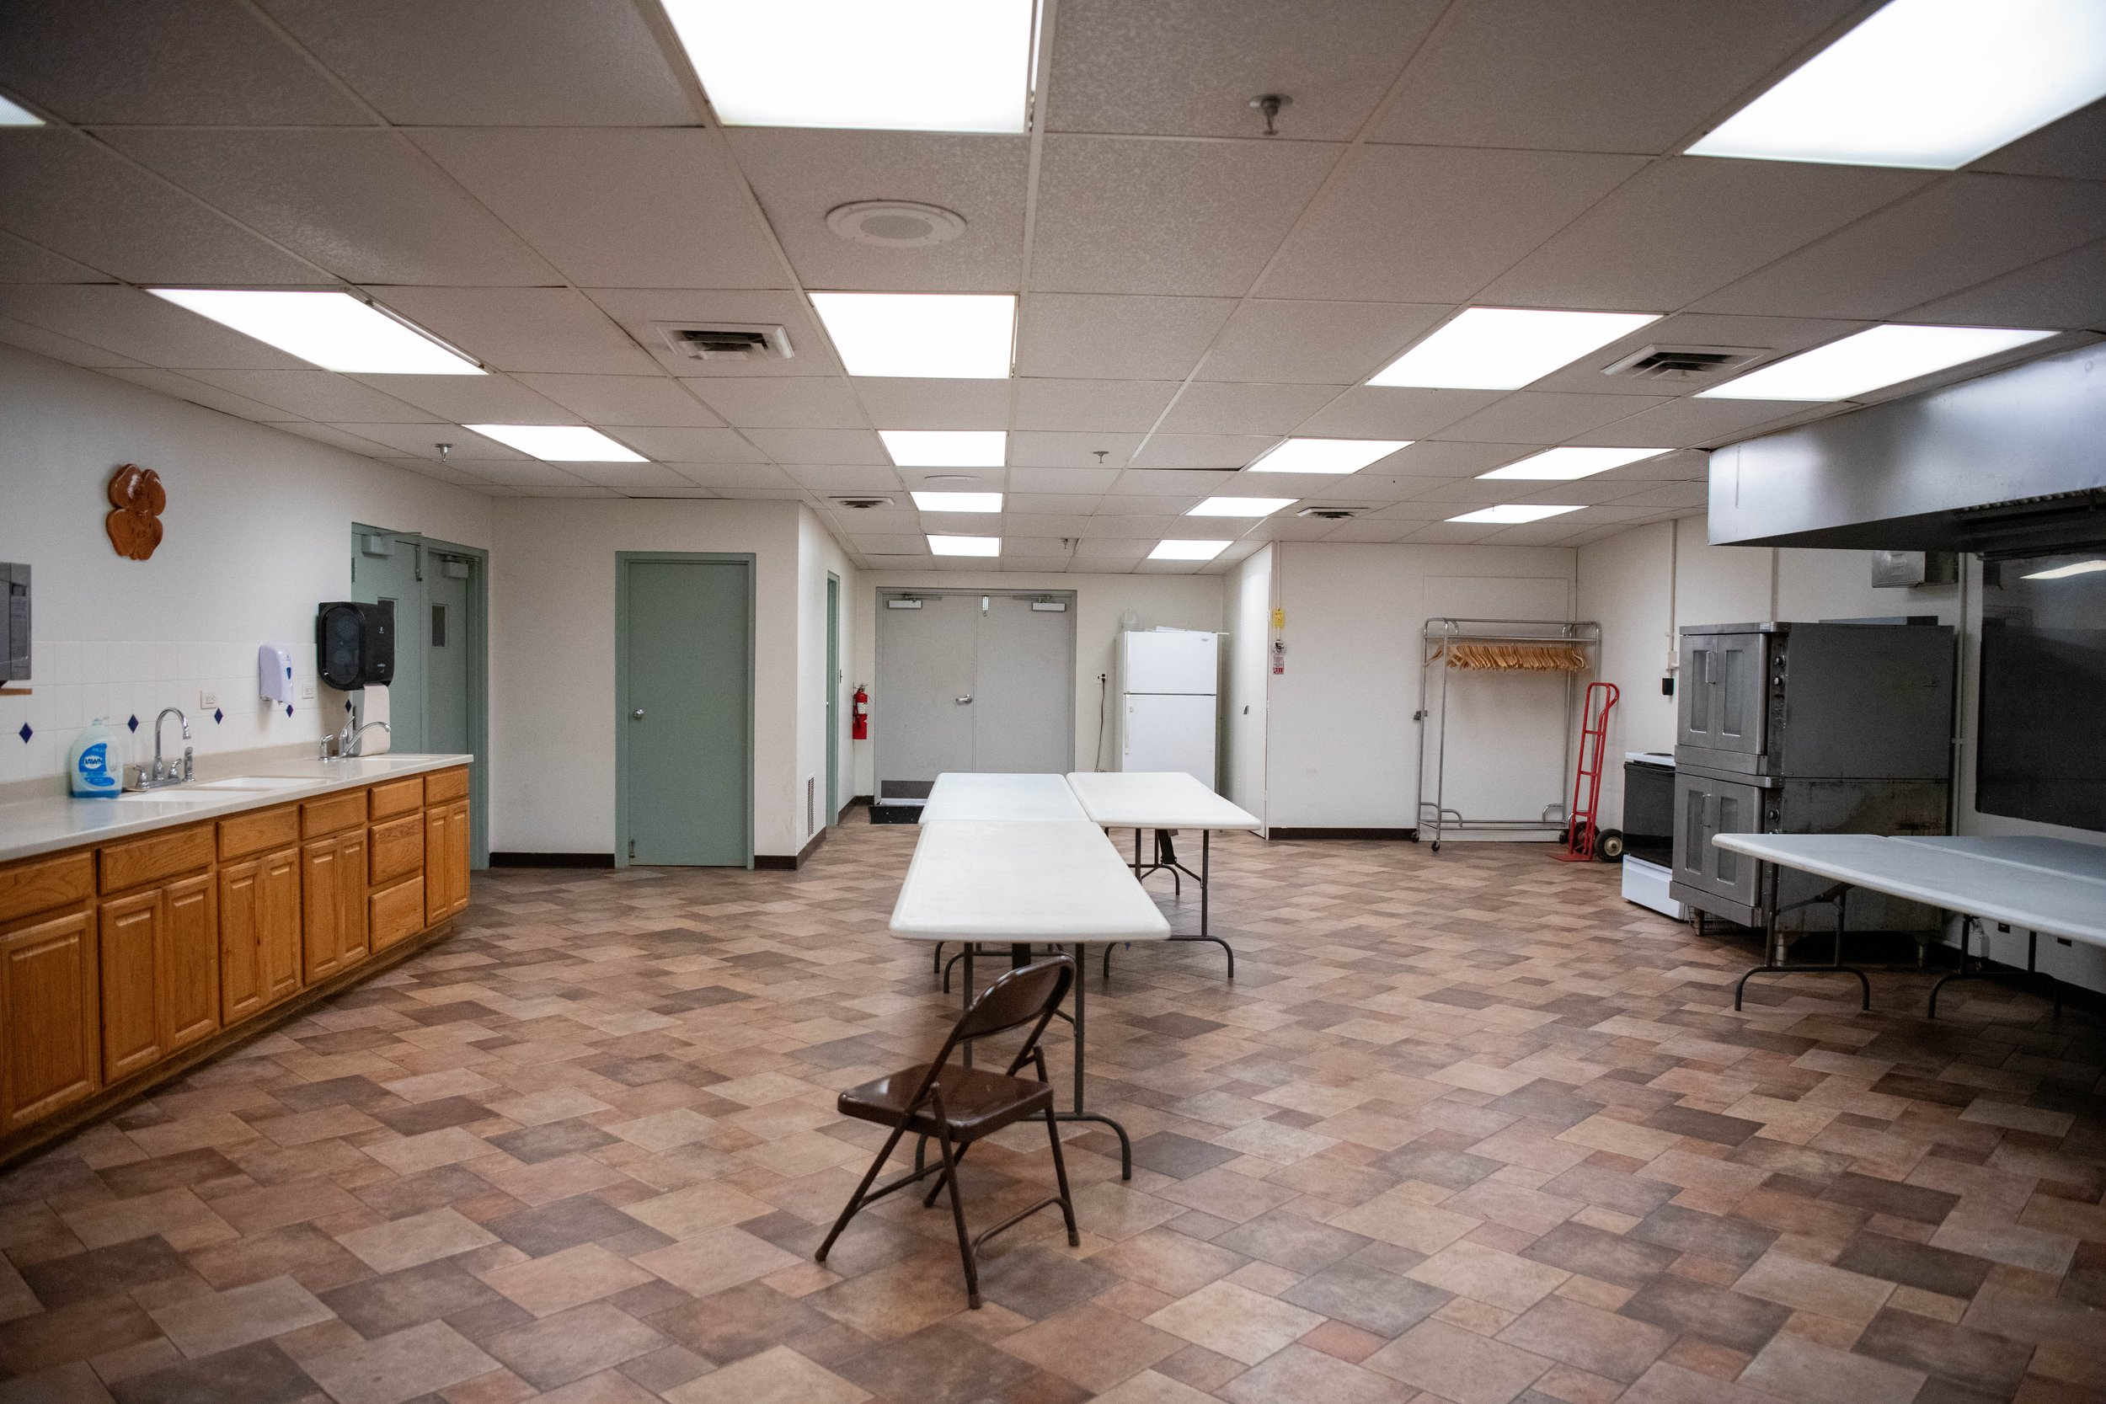
The Olde North Chapel wedding venue offers a simple elegance that is picture perfect. Constructed as one of the finest buildings in Richmond, Indiana, it offers a timeless ambiance that is reflected in this spectacular church building, circa 1866-68. It is beautifully maintained with original stained glass cathedral windows, a 3 plus story barrel ceiling, original organ pipes, a classic baby grand piano, Austrian crystal chandeliers, hand carved pews and more.
The Bridal Dressing Suite at the facility may be used for several hours prior to the wedding. In addition, there is a Banquet Room that includes tables, chairs, and chandeliers. They also offer use of their fountain punch bowl, and a full kitchen. There is a dance floor with a disco ball, ideal for the reception afterwards. They set up tables and chairs, reducing the work and cost for your celebration.
Ceremony Capacity: 200
Reception Capacity: 100

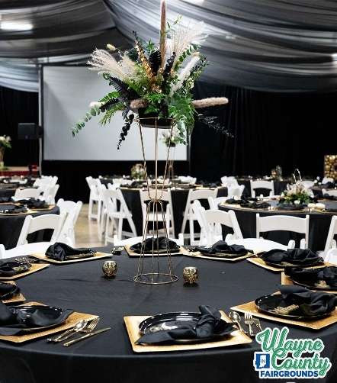
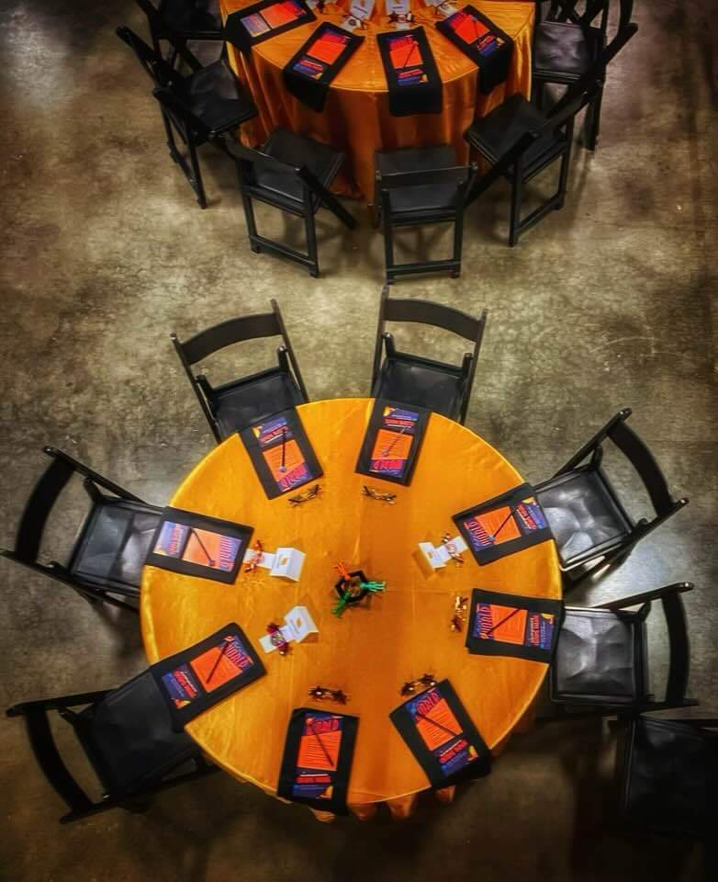
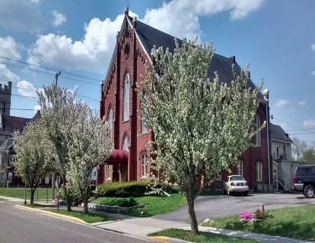
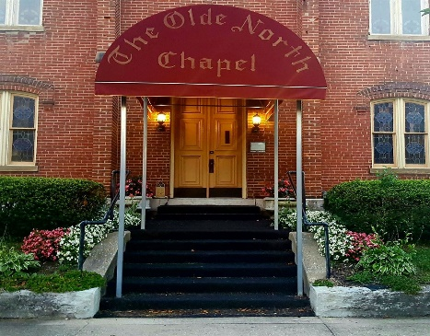

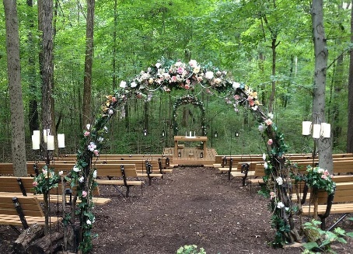
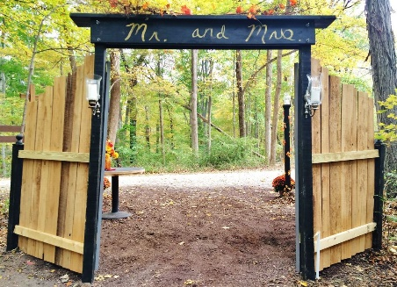
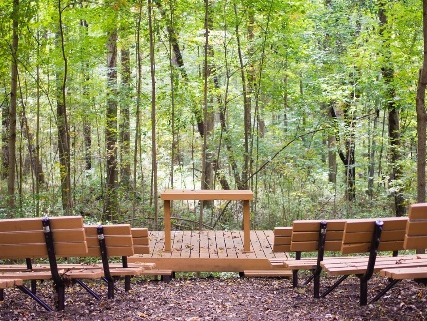
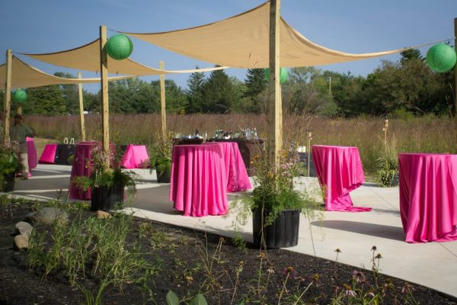
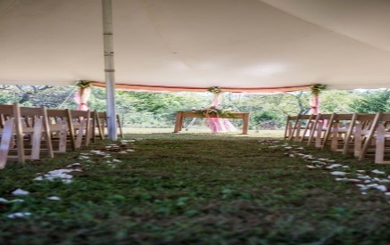
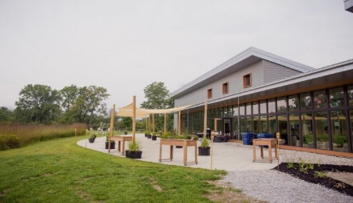
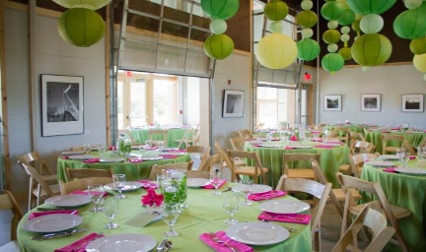
OUTDOOR VENUES
Hayes Memorial Fountain:
Located at the base of the Hayes House hill in the open vista, this beautiful memorial fountain flows from the end of April to the middle of October. The open vista is surrounded by the majestic Norway spruce and in the center is the Brice E. Hayes Memorial Fountain. The Memorial Fountain is an ideal area for a small or medium size wedding party. Guests may drive to memorial fountain area and parking is located adjacent to the site.
Capacity: 75 people

Woodland Chapel:
Located in the Beech-Maple forest, this serene outdoor sanctuary is perfect for outdoor weddings. Guests may drive to the Woodland Chapel, or enjoy a 15 minute walk from the Nature Center.
Capacity: 100 people

Hayes Arboretum
Phone: (765) 962-3745
Email: stephenhayes13@yahoo.com
There are two outdoor wedding ceremony sites to fit your theme and budget: the Woodland Chapel and Hayes Memorial Fountain.
Cope Environmental Center has a wide variety of rental venue spaces available for weddings and receptions, from classic barns, to serene spots in the woods, Surrounded by nature and outdoor beauty, this venue is the perfect place to celebrate a nature-inspired wedding or private party. Choosing Cope Environmental Center as your venue puts your dollars to great use. As a renter, you can support environmental education and celebrate important milestones at the same time! Lingle Nature Hall offers a warming kitchen ( 3-bin sink, microwave, and convection oven/stove), bathrooms, drinking fountains, yards, picnic tables, and a nature playscape for children. Tables and folding chairs are also available.
M.C. Davis Gathering Space Capacity: 100 people
Lingle Nature Hall Capacity: 50 people
Cope Environmental Center
Phone: (765) 855-3188
Email: b.evans@copeenviromental.org
Dougherty’s Orchard
Phone: (765) 478-5198
Email: doughertyorchards@gmail.com

Shady Nook Farms
Phone: (765) 914-0432
Email: events@shadynookfarms.org

Our beautiful, rustic setting is ideal for outdoor weddings, corporate events, and family functions. Nestled between the apple orchards and fields, the 4800-square-foot pavilion seats up to 200 guests. The event lawn features a gazebo and rows of wooden benches overlooking the orchards.
Included in the venue:
- 200 white chairs
- 30 60-inch round tables
- 5 8-foot rectangular tables
- New-build indoor restrooms
- 2 dressing rooms

Shady Nook Farms is a flower, herb, and tea farm owned and operated by a third generational farmer located in the rural setting of Centerville, Indiana.
They provide the perfect outdoor space for holding all your special events! The Pavilion is 26' x 40' with an attached pergola that is 30' x 40'. With use of their venue they will provide chairs for 96 people as well as 12 five foot round tables. But there is plenty of space if you so desire.

This gorgeous venue provides breathtaking views and scenery that will make your day memorable and have your friends and family talking about this day for years to come. Imagine getting married at sunset, talk about phenomenal photos. This is the perfect venue for a large or intimate wedding and reception.

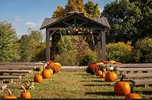
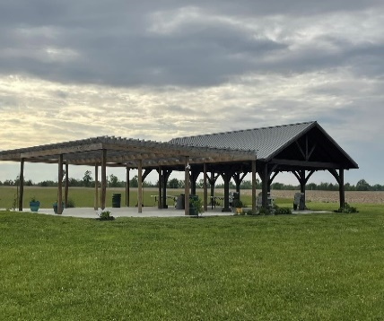
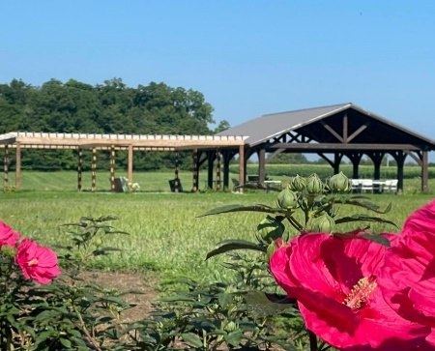
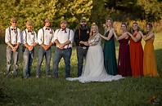

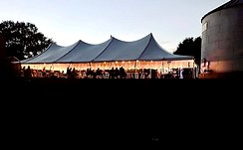
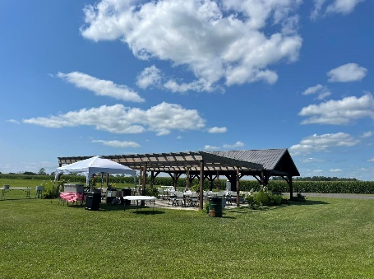
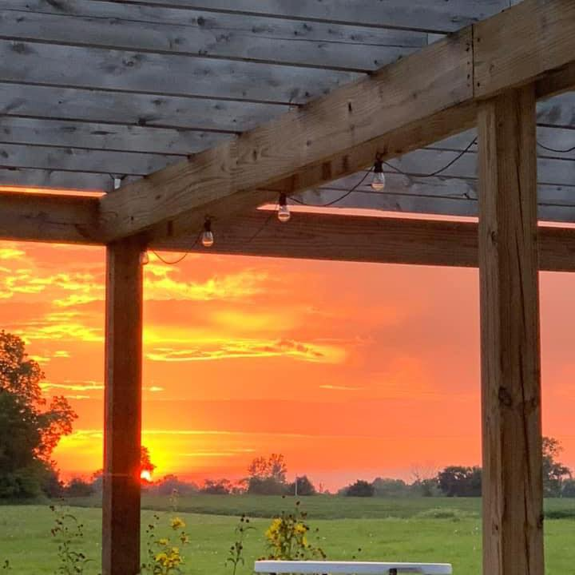

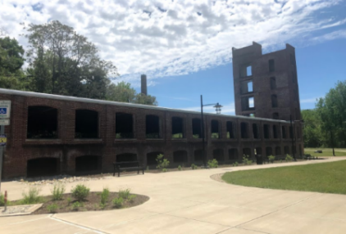
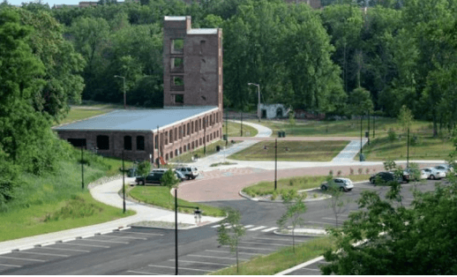
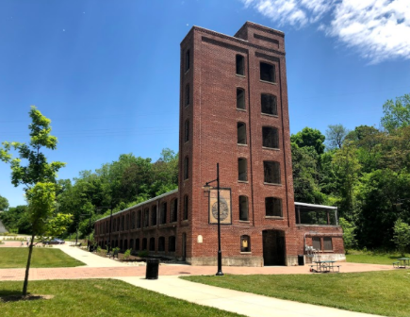
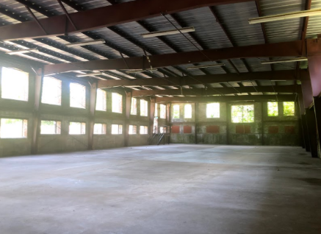
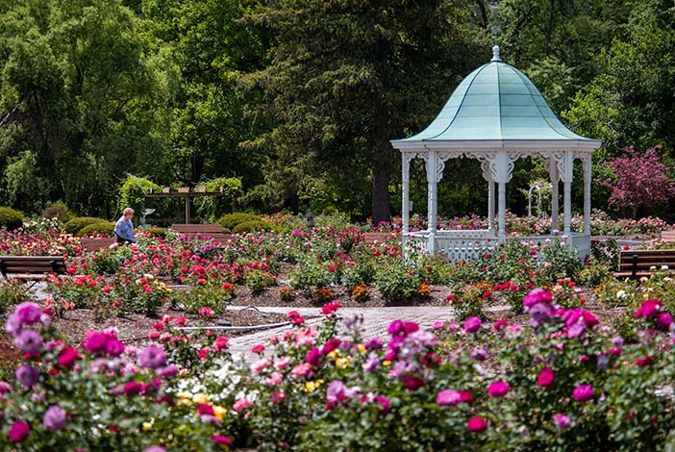
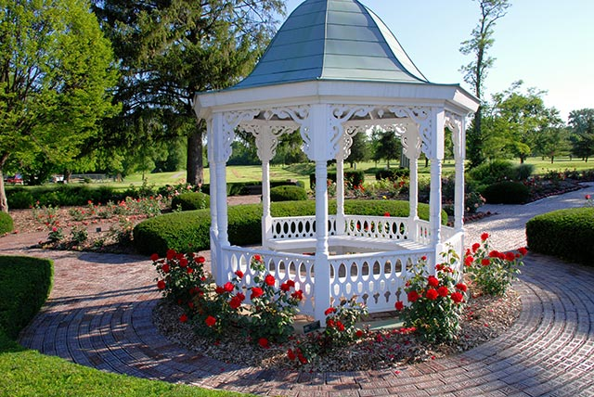
Need help planning your wedding? Ask for our wedding planning flyer!

This spacious facility is great for weddings! Star Gennett Building is centrally located in the heart of Richmond, but it has a wonderful secluded feel. Although the building lacks A/C, the many grated windows let in a pleasant breeze and plenty of sunlight. The building has an industrial feel, while also remaining a blank canvas for your desired theme.
The attractions are not just inside, however. Starr Gennett Building is surrounded by plentiful outdoor space with benches, picnic tables, a historical sidewalk, ample parking, and more! Perhaps the greatest attribute of this facility is its rich history, which is reflected in its architecture, location, and ambiance. Star Gennett Building is bound to make your event special!
Capacity:600
Starr Gennett Building
Phone: (765) 983-7275
Email: parks@richmondindiana.gov
Richmond Rose Garden
Phone: (765) 983-7275
Email: parks@richmondindiana.gov

The Victorian Gazebo at the Richmond Rose Garden is perfect for an outdoor wedding. The flourishing thirty-year-old garden highlights over 100 varieties of All American Rose Selections amidst blooming annuals, perennials, and ornamental trees that add an interesting texture to the garden. The gazebo itself is painted a traditional white color and surrounded by the elegant flowers, making it ideal for memorable photos. The Rose garden is located right inside Richmond’s Glen Miller Park. The park offers several venues to hold a great reception.

