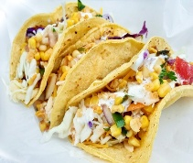
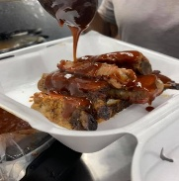
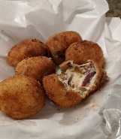
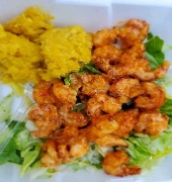
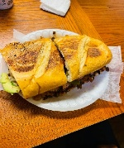
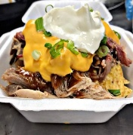
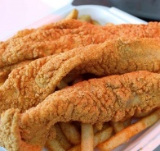
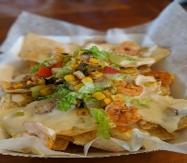
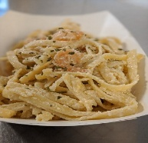
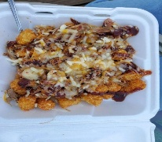

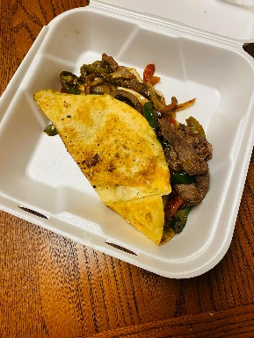
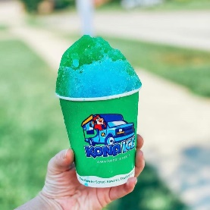
Area Food Trucks

Ann & The Pigs BBQ BBQ (765) 914-3977
Arnold’s Lunch Box Variety ( )
Ashley’s Roaming Bean Coffee (765) 580-3590
Biggie Spudz Potatoes ( )
Big Poppa’s Pork Pit BBQ (765) 277-0724
C&W Bar-B-Q BBQ (765) 238-3293
Charley’s Chops Pork Chops (937) 450-7950
China Rainbow Chinese (513) 295-8597
Danger Dogs Concessions American (219) 309-1875
El Amigo Taqueria Mexican (317) 452-0422
Fatheadz Foodtruck Comfort Food (765) 977-0988
The Ginger Gringo BBQ/Tex-Mex ( )
Frontline Coffee Company Coffee (863) 229-6096
Just Smokin’ LLC BBQ (765) 969-5909
Kona Ice Shaved Ice (859) 462-1481
L.A. Liquid Catering Alcoholic (765) 593-1325
Beverages
Lulu’s Tacos Mexican (317) 354-3466
Maggie’s Hot Dog House Dog Inspired (513) 882-6749
Phillips Family Grill Hibachi Style (765) 462-6935
Roasted-Coffee Station Coffee
Roscoe’s Coffee Coffee & (818) 679-5451
Alcoholic Beverages
Tropical Shaved Ice Shaved Ice (765) 534-4395
Ta-Jay’s Caribbean Delight Jamaican (765) 623-1625
The Big Easy, LLC. Cajun (765) 623-1625
The Fresh Side American (765) 277-1005
Tipsy Hog
Ullery’s Ice Cream Ice Cream (765) 993-1687
What the Truck American (765) 407-9145

Everyone Loves a Food Truck

