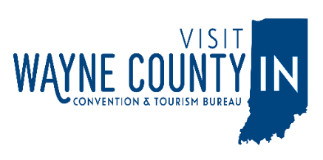
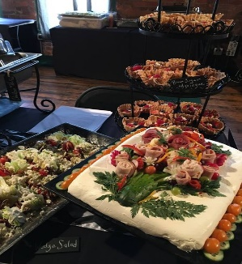
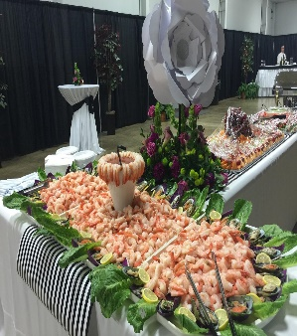
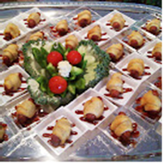
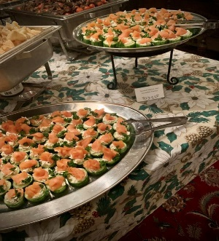
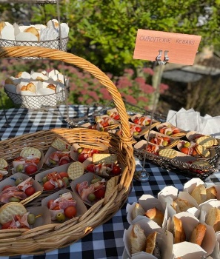
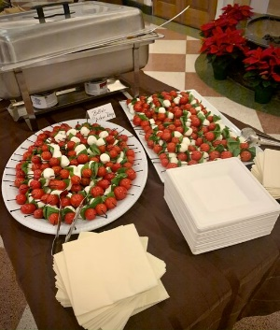
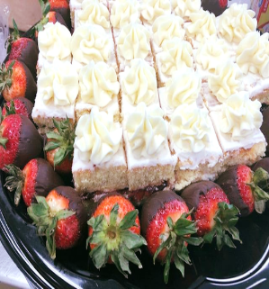
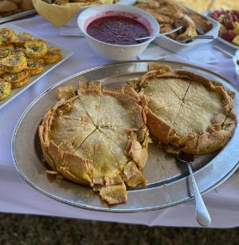
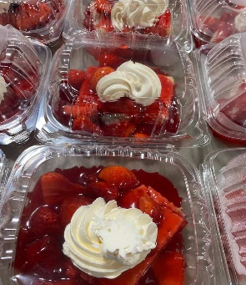
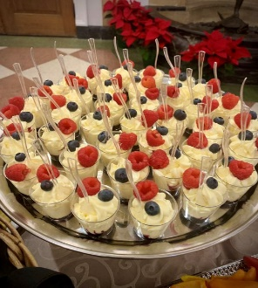
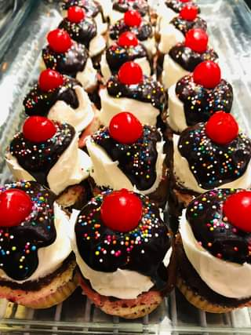
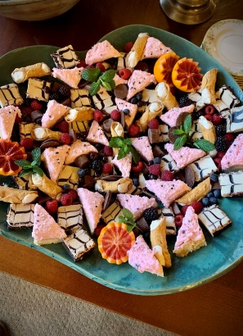
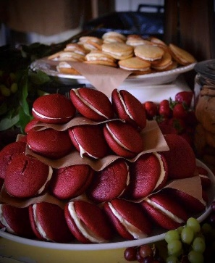
Local Catering Options
The Cater box (765) 407-9145
The Cater Box Food Service is offering small- and large-scale, casual catering for any occasion.
Downtown Deli and Catering Company (765) 488-2049
Satisfy your cravings and impress your guests with our unique catering options.
Corner Café at the Leland: (765) 598-4032
No matter what kind of food your event calls for, their experienced staff can make it unforgettable! From prepared and buffet style meals, to just desserts, and more!
Cordial Cork: (765) 983-3022
Looking for high end catering? You can find it here! The Cordial Cork offers a wide variety of high-end food for weddings, events, meetings, and more! They have a beautiful facility that can accommodate up to 60 people or they can bring the food to you.
Firehouse BBQ and Blues: (765) 488-0312
Looking for a catering service that offers brisket, ribs, pulled pork, and much more? Firehouse BBQ is the place for you. They have a room that can accommodate up to 80 people comfortably. They can also bring the BBQ to you!
Little Sheba’s: (765) 962-2999
Little Sheba’s offers quality food at affordable prices. They specialize in sandwiches, appetizers, salads, and desserts for all of your catering needs.
Old Richmond Inn: (765) 962-2247
The Old Richmond Inn offers onsite buffet or formal catering services with complete set-up and clean-up. Rental items include tablecloths, linen, china, silverware, glass, tables, champagne fountains, punch bowls, wedding accessories, and more.
.
.
Create the Experience You Desire
.

Radford’s Meat Market & Deli: (765) 962-5830
Radford’s professional catering service provides a gourmet food experience, custom made for you. They only use the highest quality ingredients, grown and produced locally whenever possible. From backyard barbeques to elegant five-course dinners, their distinguished team brings warmth and creativity to your table at an affordable price.
Other Flavors:
Buffalo Wings and Rings (765) 939-9464
Chili’s (765) 935-7591
Chipotle Mexican Grill (765) 966-3282
Cracker Barrel Old Country Store (765) 925-0881
Hot Head Burritos (765) 488-2154
Jimmy John’s (765) 373-8382
KFC (765) 939-0000
Fazoli’s (765) 935-6219
McAlister’s Deli (765) 373-3165
Olive Garden Italian Restaurant (765) 962-4300
Penn Station (765) 939-0687
Subway (765) 966-1599

